**Program1**

**a)Write an OpenMp program that computes the value of PI using Monto-Carlo Algorithm.**

**b)Write a MPI program that computes the value of PI using Monto-Carlo Algorithm.**

**a)Write an OpenMp program that computes the value of PI using Monto-Carlo Algorithm.**

#include<omp.h>

#include<stdio.h>

#include<stdlib.h>

#define SEED 35791246

int main(){

int n = 0, i, count = 0,t,r;

double z, pi, x,y;

printf("sizes: 500,1000,10000,100000 \n");

printf("threads : 1,2,4,8,16\n");

int threads[5] = {1,2,4,8,16};

longlongint sizes[4]={500,1000,10000,100000};

printf("\t\t1\t\t2\t\t4\t\t8\t\t16\n");

for(intsizeloop = 0; sizeloop<4; sizeloop++)

{

printf("\n%lld", sizes[sizeloop]);

for(intthreadloop =0; threadloop<5;threadloop++)

{

n = sizes[sizeloop];

srand(SEED);

double x = omp_get_wtime();

omp_set_num_threads(threadloop);

#pragma omp parallel for private(x,y,z)

for ( i=0; i<n; i++)

{

x = (double)rand()/RAND_MAX;

y = (double)rand()/RAND_MAX;

z = x*x+y*y;

if (z<=1) count++;

}

double y = omp_get_wtime();

printf("\t%lf\t", y-x);

pi=(double)count/n*4;

}//threadloop

}//sizeloop

return 0;

}

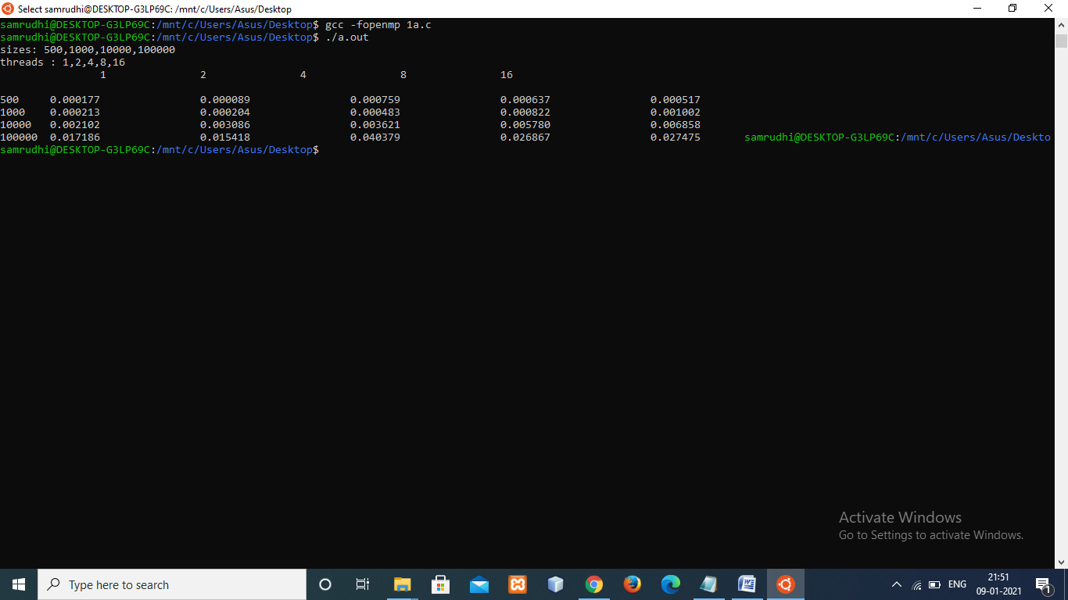

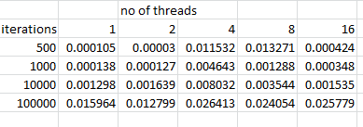

**b)Write a MPI program that computes the value of PI using Monto-Carlo Algorithm.**

**#include <stdio.h>**

**#include <mpi.h>**

**#include <stdlib.h>**

**#define SEED 3655942**

**int main(intargc,char **argv)**

**{**

**longlongintiter=1000000;**

**inti,reduced_count,reduced_iter,count=0;**

**int rank;**

**doublepi,x,y,z,t;**

**//printf("\tsize\t\t1\t\t2\t\t4\t\t8\t\t16\n\n");**

**MPI_Init(&argc,&argv);**

**iter = 1000000;**

**//printf("input %lld\n",iter);**

**MPI_Comm_rank(MPI_COMM_WORLD,&rank);**

**if(rank==0)**

**t=MPI_Wtime();**

**if(rank>0)**

**{**

**srand(SEED);**

**for(i=0;i<iter;i++)**

**{**

**x=(double)rand()/RAND_MAX;**

**y=(double)rand()/RAND_MAX;**

**z=x*x+y*y;**

**if(z<=1)**

**count++;**

**}**

**}**

**MPI_Reduce(&count,&reduced_count,1,MPI_INT,MPI_SUM,0,MPI_COMM_WORLD);**

**MPI_Reduce(&iter,&reduced_iter,1,MPI_INT,MPI_SUM,0,MPI_COMM_WORLD);**

**reduced_iter=reduced_iter-iter;**

**if(rank==0)**

**{**

**t=MPI_Wtime()-t;**

**pi=(double)reduced_count/(double)reduced_iter * 4;**

**printf("pi: %lf t: %lf\n",pi,t);**

**}**

**MPI_Finalize();**

**return 0;**

**}**

